CAMBIATA (Counterpoint and MusicXML By Instructing AI Through APIs)
An Experiment in Generating Species Counterpoint with Large Language Models
Abstract. This study investigates whether Large Language Models (LLMs) can generate two-voice species counterpoint according to Johann Joseph Fux’s Gradus ad Parnassum (1725). While earlier computational approaches, from Schottstaedt and Lewin to the FuxCP project, implemented rules directly in code, CAMBIATA conveys rules to LLMs in natural language, drawing inspiration from Fux’s dialogic pedagogy.
We wrote five species guides that translate Fux’s approach into operational instructions. Each presents rules governing consonance, dissonance, motion, and cadence in continuous prose and concludes with self-verification. We supplied these guides to Claude Opus 4.6, GPT-5.4 (ChatGPT), and Gemini 3.1 Pro to generate counterpoint in MusicXML, using worked examples and cantus firmi from the Gradus.
We evaluated 450 solutions, comprising three runs per configuration per model across configurations, using a music21-based rule checker and close reading of selected scores. Three tendencies emerge: the third species had the highest mean violation count across all three models, followed by the fifth. On average, counterpoint above the cantus firmus contained fewer violations than counterpoint below, and 31% of generations were musically identical to another run. Gemini had the lowest mean violation count (3.37 per run), followed by ChatGPT (3.98) and Claude (8.92). Gemini produced the fewest dissonance-treatment violations, ChatGPT exhibited recurrent cadential errors, and Claude showed persistent difficulties with dissonance treatment. In our qualitative assessment, the solutions approached the quality of competent student work. These findings demonstrate both the potential and the limitations of large language models for generating rule-compliant species counterpoint.
Keywords: species counterpoint, Johann Joseph Fux, Gradus ad Parnassum, large language models, computational music theory, rule compliance, MusicXML, music21, counterpoint pedagogy.

Introduction
[0.1] This article introduces CAMBIATA (Counterpoint and MusicXML By Instructing AI Through APIs), a system developed to assess whether Large Language Models (LLMs) can generate two-voice species counterpoint that complies with compositional rules. CAMBIATA delivers to three large language models (Claude Opus 4.6, Gemini 3.1 Pro, and GPT-5.4; hereafter Claude, GPT, and Gemini) a task prompt, a species guide distilled from Johann Joseph Fux’s 1725 treatise Gradus ad Parnassum, a worked MusicXML example, and output-formatting instructions; it receives back a MusicXML file, which is then parsed by a music21-based evaluator (Cuthbert and Ariza 2010) against the Fuxian rule set. The evaluation corpus comprises 450 solutions: three runs for each combination of five cantus firmi, two counterpoint placements (above and below the cantus firmus), five species, and three models.
[0.2] The study is organized around a central question: can structured natural-language instruction enable LLMs to produce rule-compliant species counterpoint? Three subsidiary questions naturally follow: how does compliance vary across the five species, across the three models, and with the position of the counterpoint—above or below the cantus firmus? We hypothesize that rule compliance will decline as species requirements become more complex. We also examine which rules are violated most frequently and how these patterns vary across models, species, and voice placements. Because repeated LLM calls can yield different outputs and adherence to the rules is not guaranteed, we address these questions through systematic evaluation of the full corpus.
[0.3] Rule-based approaches have a long history in computational species counterpoint: Schottstaedt (1984) encoded Fux’s rules as a system of weighted IF-THEN statements, Lewin (1983, 1985) organized the five species into hierarchically structured prescriptions and proposed a “Global Rule” implemented in a computer program, and this algorithmic lineage has continued through optimization methods (Herremans and Sörensen 2012, 2013; Komosinski and Szachewicz 2015) to the constraint-programming formalizations of the FuxCP project, which enforce a formalized set of contrapuntal constraints (Wafflard 2023; Lamotte 2024). Corpus-based approaches include Cope’s recombinant Experiments in Musical Intelligence (1989, 1996), neural models trained on Bach’s chorales (Hadjeres, Pachet, and Nielsen 2017; Padilla and Conklin 2018), and statistical models of Palestrina-style counterpoint (Padilla and Conklin 2018). CAMBIATA combines explicit rule instruction with generation by a pretrained language model. During generation, the compositional rules are supplied in natural language rather than enforced through executable constraints (see Appendices 1–5). The experiment tests how reliably LLMs can follow explicit contrapuntal instructions, using automated rule checking alongside qualitative score analysis.
[0.4] The article is organized in two parts. The first explains the architecture and methodology of CAMBIATA: the suitability of species counterpoint as a benchmark, the development of the species guides, the prompting strategies adopted, and the use of MusicXML to represent musical inputs and outputs. The second compares the three models through statistical evaluation of the corpus and qualitative analysis of selected scores, with the latter organized by species. Together, these analyses connect the computational assessment of rule complicance with the interpretation of species counterpoint through historical music theory.

1. Architecture and Methodology

Species Counterpoint as a Benchmark for LLM Rule Compliance
[1.1] This study examines how LLMs apply explicit musical rules when generating species counterpoint. Recent research has produced various benchmarks for evaluating LLMs on musical knowledge, symbolic music understanding, and reasoning about musical scores (Yuan et al. 2024; Zhao et al. 2025; Mundada et al. 2025; Dai et al. 2025; Wang et al. 2025). Our research builds on the work of Pond and Fujinaga (2025), who evaluated LLMs using questions from a Royal Conservatory of Music (RCM) Level 6 theory examination and found that pedagogical prompting strategies (in-context learning and chain-of-thought prompting) improved model performance on music theory tasks. We extend this line of inquiry from answering music theory questions to generating solutions to species counterpoint exercises that conform to the rules codified by Johann Joseph Fux’s Gradus ad Parnassum (1725). Species counterpoint is well suited as a benchmark for this study. Fux’s treatise has served as a foundation of contrapuntal training for three centuries, shaping the compositional education of Mozart, Beethoven, Brahms, and others, and it remains a standard component of conservatory curricula (Schubert 2008; Green and Jones 2011).
[1.2] What makes Fux’s framework appropriate for evaluating LLMs is the nature of its rules. The five species introduce constraints of progressively increasing complexity. First species (note against note) establishes the foundational rules governing consonance, parallel motion, and cadential formulas, testing the model’s basic intervallic awareness. Second species (two notes against one) introduce the treatment of passing dissonances on weak beats. Third species (four notes against one) extend dissonance treatment to more complex melodic patterns. Fourth species (syncopation) introduce prepared and resolved suspensions. Fifth species (florid counterpoint), which Fux describes as combining elements from the four preceding species, but for which he provides limited guidance on species selection and variation strategies, tests the model’s ability to coordinate multiple rule systems simultaneously. Most of the rules are explicit, hierarchically organized, and amenable to objective evaluation: one can determine unambiguously whether a given solution contains parallel fifths, an unprepared dissonance, or an incorrect cadential formula. This structure supports comparisons of rule compliance across species with different contrapuntal requirements.
[1.3] Our methodology is text-based and draws on Fux’s own pedagogical approach. Just as Fux cast his treatise as a dialogue between the student Joseph and the master Aloysius, we instruct the LLM through carefully designed prompts and supplementary guides adapted from Fux’s rules. Restricting our scope to two-voice counterpoint, we tasked three LLMs with composing solutions to two-voice counterpoint exercises in first through fifth species, each using a custom pedagogical guide adapted from Fux’s rules. This study evaluates observable rule compliance without determining the internal mechanisms responsible for it.

Prompting, Generation and Evaluation
[1.4] The CAMBIATA workflow draws explicitly on established techniques from the prompt engineering literature. Drawing on chain-of-thought prompting research (Wei et al. 2022; Kojima et al. 2022), our task prompts instruct the model to analyze the cantus firmus, plan the counterpoint, and check its compliance with the supplied rules before returning the MusicXML output. We apply role prompting (Shanahan et al., 2023), assigning the model the persona of a specialist in sixteenth-century species counterpoint and an expert in MusicXML encoding. We supply in-context examples (Brown et al. 2020) through a species-specific MusicXML file containing Fux’s solutions above and below the cantus firmus in D, with an instruction identifying the relevant voice placement. The prompts also instruct the model to check compliance with the supplied rules and correct any violations before returning its response. This self-check instruction operates within a single generation request; the evaluator’s feedback is not returned to the model for revision.
[1.5] During generation, compositional rules are conveyed to the model in natural language, as one would explain them to a student, rather than enforced by a constraint solver. One might object that an LLM could also have been used to generate an algorithmic counterpoint solver that translates the species guides into executable code. Such an approach, however, would shift the investigation toward LLM-assisted construction of a counterpoint solver, bringing it closer to the constraint-based methodologies discussed above (Wafflard 2023; Lamotte 2024). CAMBIATA investigates how successfully LLMs generate solutions to Fux’s species-counterpoint exercises when compositional rules are supplied in natural language. The diagram in Figure 1 presents the resulting workflow, and the following paragraphs define each step, proceeding from top to bottom.
[1.6] The system prompt begins by assigning the model a specialist role: “You are a specialist in 16th-century species counterpoint as codified by Johann Joseph Fux in Gradus ad Parnassum, and an expert in the MusicXML encoding format.” The user prompt specifies the task of composing a counterpoint to the supplied cantus firmus and includes the task instructions, species guide, reference MusicXML example file, output-format instructions, and cantus firmus encoded in MusicXML.

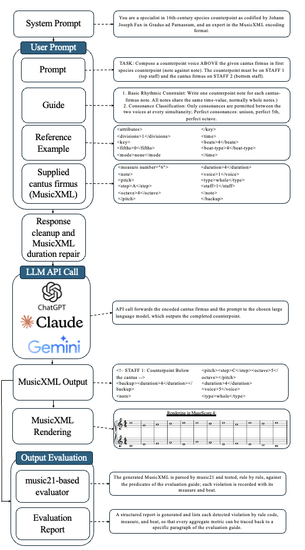
Figure 1.

CAMBIATA’s single-pass generation and evaluation workflow. Solid arrows indicate workflow connections; dashed arrows connect components to illustrative excerpts.

[1.7] The guide contains the compositional rules that the model is instructed to follow when composing the counterpoint. These rules are expressed in natural language rather than as executable constraints. The guide translates the pedagogical framework of Fux’s Gradus ad Parnassum into a set of operational rules covering vertical intervals, motion categories, cadence treatment, tritone prohibition, modal integrity, and the specific obligations of the species at hand. Including the guide in the user prompt makes the study’s operational interpretation of Fux’s rules available during generation, supplementing any contrapuntal knowledge acquired during pre-training.
[1.8] The supplied example is a complete MusicXML document containing worked solutions by Fux and illustrating both contrapuntal writing and MusicXML encoding. We reserved the cantus firmus in D for the reference solutions supplied as in-context examples, following the use of task demonstrations in prompting research (Brown et al. 2020). Generated solutions may reflect both application of the supplied rules and adaptation of patterns in the reference examples. We therefore excluded cantus firmus in D from the evaluation set to reduce opportunities for direct reuse of the supplied solutions. This separation does not rule out adaptation of those solutions. The choice of the D cantus firmus, rather than any other, follows Fux himself: for the introduction of each new species, Fux uses the same cantus in D and provides solutions both above and below the given line, so that offering this exact exercise as the example is in keeping with the spirit of the treatise (Fux [1725] 1965, 27–67).
[1.9] The formatting instructions are output constraints that specify exactly what the model should return: “Emit ONLY the MusicXML file. No prose, no analysis, no commentary, no Markdown. […] The file must be directly renderable by MuseScore without any manual editing.” Without explicit instructions to the contrary, a model trained to produce conversational text might precede or follow its MusicXML output with explanatory prose, which could prevent notation software from parsing the response directly as MusicXML. The intended output is a complete two-staff MusicXML score containing the supplied cantus firmus and the generated counterpoint. A valid score can then be rendered in notation software and assessed against the study’s formalized contrapuntal rules.
[1.10] The assembled prompt and user prompts are transmitted to the selected model through an API call. The prompt’s natural-language instructions and MusicXML representation can be supplied to each model through provider-specific API interfaces, enabling the comparative evaluation of Claude, ChatGPT, and Gemini. Generation settings were configured separately for each model. Claude was run at temperature 0.0 with extended thinking disabled. Gemini was run at temperature 1.0, with its thinking level left at the default “high.” GPT-5.4’s reasoning effort was also set to “high,” a configuration in which the API does not support the temperature parameter.
[1.11] Once generated, the file enters the evaluation branch of the workflow: our custom music21-based evaluator parses it, tests it rule by rule against the evaluation guide’s predicates, and compiles a report that records each detected violation with its measure and beat.

Methodological Considerations

Choice of MusicXML
[1.12] An important methodological choice for this study is how to represent musical information. Pond and Fujinaga (2025) compared LLM performance on a Royal Conservatory of Music (RCM) Level 6 theory examination encoded in four formats (ABC, Humdrum, MEI, and MusicXML). Performance varied with the encoding format, model, and prompting condition. With contextual prompting, MEI yielded the highest scores for two models, while MusicXML yielded the highest score for the third. Our study adopts MusicXML because it is a widely supported interchange format that integrates with both MuseScore for score rendering and our music21-based evaluator. This compatibility provides a practical basis for generating and evaluating complete two-voice counterpoint solutions. MusicXML represents pitches, durations, voices, and measures in a structured format, providing the information needed for score rendering and automated counterpoint evaluation.

The Redaction of the Species Guides
[1.13] The guide provides the compositional rules and constraints governing generation. We restricted our study to two-voice counterpoint across all five species and developed one guide for each species. This scope allowed us to concentrate on specifying the substantial set of constraints involved in two-voice writing and evaluating compliance with them. The complete versions of all five guides are provided as appendices.
[1.14] To examine how the models responded to species-counterpoint requests without an accompanying species guide, we conducted a preliminary batch of generations across all three models. The generations succeeded in the sense that well-formed output was produced in every case, but regardless of the requested species, all three models produced one-note-against-one-note textures in these preliminary textures. Under these prompting conditions, the models produced notated music but did not realize the requested species beyond first species. This observation provides a practical rationale for supplying explicit species guides.
[1.15] Composing guides that distill Fuxian counterpoint into a format usable by a large language model presents significant conceptual challenges, and a structurally comparable difficulty was encountered in the algorithmic formalizations of the Gradus ad Parnassum. As Wafflard observes, the Gradus was written for an eighteenth-century audience and must be read critically: several rules can sometimes be consolidated into one, others require translation into modern logical language, and still others are never explicitly stated, remaining implicit in Fux’s musical examples and in the conventions of his time (Wafflard 2023, 11). The treatise is structured as a pedagogical dialogue, rhetorically effective for a human reader but syntactically convoluted, and it does not deliver rules in a straightforward, extractable style (Wafflard 2023, 11). To keep the prompts focused on the compositional task, we organized the guides around explicit operational instructions and refined them through iterative dialogue with the LLMs during guide development.
[1.16] This methodology, while perhaps counterintuitive, proved particularly productive. Analyzing compositional output is one diagnostic tool: recurrent errors across multiple outputs can identify rules whose formulation warrants review. However, output analysis alone does not necessarily indicate how a rule should be revised. Iterative dialogue with the model proved valuable at this juncture, allowing us to examine the models’ explanations, identify potentially underspecified or ambiguous formulations, and test revised phrasings before incorporating them into the guides. For example, we revised the cadential instructions to specify the interval progression (a major sixth resolving to an octave when the cantus firmus is in the lower voice, or a minor third resolving to a unison when it is in the upper voice) and any required accidental. A similarly descriptive, step-by-step specification of the metric placement of the dissonances resolved a recurring error in third and fourth species. We also incorporated a structured checklist into each guide, instructing the model to review its proposed solution and correct any identified errors before returning the final output.
[1.17] This methodology does not, however, displace human judgment. Given the well-documented tendency of LLMs to generate plausible-sounding but factually incorrect content, every modification to the guides was cross-checked against the primary source. We also drew on two supplementary sources. The first is Schubert (2008), whose set of soft rules we found useful for formulating instructions intended to steer the models away from technically permissible but stylistically awkward counterpoint. The second is Lewin (1983), whose formulation of the prohibition of tritones outlines by stepwise motion and rule for using B♭ to avoid such outlines we borrowed; both instances are visible in the second-species guide, reproduced in Appendix 2.
[1.18] A third problem concerns metrical hierarchy. In the Gradus ad Parnassum, Fux uses a binary meter with thesis and arsis terminology, which define his treatment of passing tones in second species and syncopations in fourth species. For the third- and fifth-species guides, we used explicit numbering of the four quarter-note positions within each measure to describe the placement of consonances and dissonances. This numbering makes the quarter-note subdivisions explicit in the guides while retaining the underlying binary division into thesis and arsis. At this finer level, one can state, for example, that the second beat may be either consonant or dissonant, and that the accented passing tone on the third beat is straightforward to describe. Similar considerations apply to the fifth species, where the free combination of the preceding species benefits from being articulated at the quarter-note level, particularly for the use of diminutions in syncopations.

The Evaluation Guide and Its Computational Implementation
[1.19] The evaluation guide was developed alongside the species guides, rather than simply derived from them. As the evaluation criteria were formulated, it became necessary to define the rules in the species guides with sufficient precision to support a consistent assessment of the model’s output. This, in turn, led to further refinement of the species guides. The guide development process was therefore iterative: clarifying a rule made it possible to formulate a corresponding evaluation criterion, while the evaluation requirements revealed where the rule itself needed to be made more precise. This reciprocal refinement was an important, and initially unanticipated, aspect of the guide-writing process.
[1.20] The evaluation guide’s rules are organized into two rule sets, which reflect Fux’s cumulative pedagogical content. Universal rules, designated U1 to U17, apply across all five species and address general requirements concerning opening and final intervals, voice crossing, spacing, the treatment of tritones as vertical intervals, melodic leaps, and melodic outlines, modal integrity, melodic range, and the basic requirement of varied motion. Species-specific rules, designated S1-x through S5-x, specify the requirements and permitted procedures for each species: the consonance-only regime in the first species, the passing-tone treatment and downbeat discipline in second, the use of the nota cambiata the in third, the preparation and resolution of suspensions in the fourth, and the combination of rhythmic patterns from the preceding species in the fifth.
[1.21] The guiding principle behind drafting each rule was precision in formulation. The species guides include formulations based on implicit musical judgment, such as that a line should be singable and that intervallic variety should be maintained. These instructions are intended to guide generation but require further specification for automated assessment. Therefore, writing the evaluation guide involved expressing the rules selected for automated assessment as predicates, each defining a test for compliance or violation in the relevant musical context. If a rule was not yet testable, we either refined its formulation or reserved it for qualitative analysis in Part 2.
[1.22] The nota cambiata of third species offers a clear example of the writing challenge associated with the evaluation guide. Fux introduces the figure almost in passing, as an exception to the general treatment of the dissonant second quarter (Fux [1725] 1965, 51): a dissonant second note may proceed to a consonance by a downward skip of a third, with the subsequent note repairing the line stepwise. For a human reader, the gesture is recognizable at sight; for a predicate that must return a verdict on any four-quarter grouping, recognizability is insufficient, and the pattern had to be specified as a succession of intervals, contour directions, and metric positions, with each harmonic interval measured against the cantus-firmus note sounding at that position. Once the rule could be tested, the corresponding passage in the prescriptive document was rewritten to match the precision of the predicate.
[1.23] A second class of rules resisted precise formulation for different reasons. The prohibition of the outlined tritone is straightforward to state but difficult to formalize over a horizontal span: one must decide over what duration a tritone frame counts as outlined, whether a stepwise passage that continues through the interval is to be accepted (as Fux’s rule in fact permits), and whether an accidental removes the outlined tritone and therefore prevents the passage from being flagged. A related issue is the cost of implementing such rules: Lewin marks with an asterisk those rules he teaches in class but did not build into his program, among them the avoidance of “bad local outlines of augmented and diminished intervals,” explaining that “it did not seem worth the amount of time it would take to implement them, to exclude the relatively few solutions they would catch beyond those already excluded” (Lewin 1983, 42). We implemented the rule in a first approximation, flagging canonical cases such as the stepwise passage F-G-A-B♮-A in which the line reverses direction at the boundary of an outlined tritone; the finer calibration of duration and ficta placement is acknowledged as a known limitation. Finally, each predicate is evaluated as a binary condition, with no weighting for relative severity. This decision responds to the critique of weighted-sum approaches raised by Komosinski and Szachewicz (2015): since Fux himself offers no numerical hierarchy among his rules, assigning weights would import a scale of values foreign to the treatise.
[1.24] We implemented the evaluation guide’s rules in an automated evaluator. The evaluator is a computational reader built on top of the Python library music21 (Cuthbert and Ariza 2010). The evaluator uses music21 to parse MusicXML into structured musical objects and to represent intervals, voice-leading motion, metrical positions, and ties for use in the evaluation predicates. Each score is loaded, and its two voices are isolated, with the position of the cantus firmus supplied as context. The counterpoint is aligned against the cantus firmus at the temporal granularity proper to the species. The subset of rules applicable to the species is tested in turn, and violations are annotated with the measure and beat at which they occur, so that a human evaluator can open the score and read the offending passage at once. From a music-theoretic standpoint, the key architectural feature is the one-to-one correspondence between the evaluation guide and the reader: each U or S code is implemented by a single predicate, and no predicate exists in the reader without a corresponding code in the guide. Reported violation counts can therefore be traced backward, from aggregate metric to violation category, from category to rule code, from code to its paragraph in the evaluation guide, and from that paragraph back to the species guides. This traceability makes the relationship between the reported violation counts and our formalization of the contrapuntal rules open to critical inspection.

2. Analysis of the Generated Corpus

Overview
[2.1] The generation corpus was structured as follows: five cantus firmi, two counterpoint placements (above and below the cantus), five species, and three models, for a total of 50 distinct configurations per model. Each model was queried through its own API in separate collection sessions in April 2026 (Claude Opus 4.6, GPT-5.4, and Gemini 3.1 Pro), with batch sizes adjusted to the observed failure rates. Gemini was sampled four times per configuration as a safety margin against API failures (200 runs). Claude was sampled three times per configuration, with one additional run initiated manually for a single configuration (151 runs). ChatGPT required additional reruns to compensate for the parse failures encountered in early batches, with the second species oversampled (60 of the 224 ChatGPT runs) because parsing failures were initially concentrated there. The combined initial corpus therefore comprised 575 model outputs. Of these, 47 files failed XML parsing prior to the counterpoint analysis (46 by ChatGPT, 1 by Claude). The 46 ChatGPT files were repaired through automated XML recovery, a procedure that corrects malformed tags; the single Claude file, which contained only plain text rather than MusicXML, was excluded. To ensure an equitable comparison across models, the first three runs per configuration were retained, yielding a symmetric evaluation corpus of 450 runs: 150 per model, distributed as three runs for each of 50 configurations. Pre-repair parsing success rates are reported separately as M6, distinguishing output parsability from contrapuntal rule compliance. A subsequent duplicate-detection analysis revealed that within each model-configuration combination, counting all but one representative of each group of musically identical outputs yielded 141 additional copies (31.3% of the 450 evaluated solutions). This finding is discussed at the end of the statistical evaluation. The automated checker detected a total of 2,440 violations across the 450 evaluated runs, which serve as the primary basis for the statistical analysis.
[2.2] The analysis proceeds along two complementary axes, one statistical and one score-based. The statistical approach yields a global picture of the corpus, making recurring error patterns and aggregate performance tendencies tractable. Qualitative assessment complements the statistical analysis by addressing stylistic features not captured by the automated checker and illustrating how the reported error patterns manifest in individual scores. The examples discussed in the qualitative section have been deliberately selected for their capacity to illustrate a characteristic stylistic feature, a recurrent generative pattern, or a notable behavioral response to the guide’s directives. This selection draws on disciplinary judgment and supports close examination of particular musical features, although it limits conclusions about their prevalence across the corpus. The rigour of the qualitative analysis depends on explicit selection criteria and interpretations grounded in the musical details of each example.

Statistical Evaluation

Evaluation Metrics
[2.3] Five metrics, derived from the rule set formalized in the evaluation criteria guide (Appendix 6), structure the presentation of the statistical results; each aggregate metric is computed on the full 450-run corpus. M1 reports the mean number of rule violations per run, computed globally for each model and per species, and accompanied by the standard deviation of the violation counts across the runs of each subgroup. M2 characterizes the distribution of each model’s output across four tiers, expressed as percentages: perfect runs (0 violations), low-violation (1–3), moderate-violation (4–5), and high-violation (6 or more); these thresholds do not constitute criteria of acceptability but serve to characterize each model’s level of rule compliance. M3 organizes each model’s violations into four families of contrapuntal rules and a residual category: melodic contour, parallel motion, dissonance treatment, cadential, and other, reporting for each pair model × category the average number of violations per run and that category’s share of the model’s total violations. M4 reports the average number of violations per run, computed separately for configurations in which the counterpoint lies above the cantus firmus and those in which it lies below. M6, the only purely technical metric, reports the percentage of generated files that parse successfully as well-formed MusicXML, measured on the raw pre-repair output.

Comparative Overview (M1, M2)
[2.4] From a global perspective, Gemini 3.1 Pro achieved the lowest average violation count at 3.37 per run (n = 150), followed by ChatGPT (GPT-5.4) at 3.98 (n = 150) and Claude Opus 4.6 at 8.92 per run (n = 150).
 |  | Global | 1st sp. | 2nd sp. | 3rd sp. | 4th sp. | 5th sp.
ChatGPT | avg | 3.98 | 1.67 | 4.40 | 7.67 | 2.47 | 3.70
ChatGPT | SD | 3.56 | 2.12 | 4.05 | 3.12 | 2.32 | 2.44
Claude | avg | 8.92 | 2.03 | 10.63 | 14.30 | 8.37 | 9.27
Claude | SD | 5.92 | 1.97 | 3.47 | 4.67 | 6.35 | 4.19
Gemini | avg | 3.37 | 0.20 | 2.27 | 7.63 | 2.83 | 3.90
Gemini | SD | 3.35 | 0.48 | 1.79 | 3.29 | 2.63 | 2.20
Example 2. Average violations per run by species (M1), raw corpus (n = 450).
[2.5] Going deeper with M2, the distribution profiles reveal distinct output characteristics. Gemini’s production divides into 27% perfect, 20% low-violation, 30% moderate, and 23% high-violation runs. ChatGPT shows a weaker profile (19% perfect, 21% low, 30% moderate, 30% high), while Claude’s profile is heavily concentrated in the upper tier (6% perfect, 8% low, 19% moderate, 67% high violation).
Model | Tier | Global | 1st sp. | 2nd sp. | 3rd sp. | 4th sp. | 5th sp.
ChatGPT | perfect | 19% | 53% | 13% | 0% | 30% | 0%
ChatGPT | low | 21% | 13% | 27% | 0% | 30% | 33%
ChatGPT | moderate | 30% | 27% | 33% | 20% | 27% | 43%
ChatGPT | high | 30% | 7% | 27% | 80% | 13% | 23%
Claude | perfect | 6% | 30% | 0% | 0% | 0% | 0%
Claude | low | 8% | 33% | 0% | 0% | 7% | 0%
Claude | moderate | 19% | 33% | 3% | 0% | 33% | 27%
Claude | high | 67% | 3% | 97% | 100% | 60% | 73%
Gemini | perfect | 27% | 83% | 20% | 0% | 30% | 0%
Gemini | low | 20% | 17% | 40% | 0% | 13% | 30%
Gemini | moderate | 30% | 0% | 37% | 27% | 43% | 43%
Gemini | high | 23% | 0% | 3% | 73% | 13% | 27%
Example 3. Distribution profile by species (M2), raw corpus (n = 450).
[2.6] The species difficulty ranking is consistent across the three models: the first species is systematically the easiest, the third species the hardest. At either end of this ordering, the models’ profiles converge in shape. In the first species, the two lower tiers (perfect and low-violation runs together) account for the majority of each model’s output, with Gemini reaching 100%, ChatGPT 66%, and Claude 63%. In third species, the pattern inverts: the high-violation tier dominates, capturing 80% of ChatGPT’s runs, 73% of Gemini’s, and 100% of Claude’s. No model produces a single perfect run in third or fifth species. Claude’s output collapses beyond first species: in second species, 97% of runs fall in the high-violation tier; in third species, 100%. Neither of the other two models exhibits this pattern.
[2.7] One unexpected finding concerns ChatGPT’s first species. Although this model achieves 53% perfect runs in first species, 7% of its first species runs nonetheless fall in the high-violation tier, a category absent for Gemini (0%) and only marginally present for Claude (3%) at this level. These high-violation runs concentrate on cadential codes rather than on broadly distributed rule violations. When ChatGPT fails in first species, it fails at the cadence; when it succeeds, it produces a low-violation or flawless exercise.

Violation Category Profiles (M3)
 | Melodic contour | Parallel motion | Dissonance treatment | Cadential | Other | Total (M1)
ChatGPT | 0.73 (18%) | 0.40 (10%) | 0.69 (17%) | 0.88 (22%) | 1.28 (32%) | 3.98
Claude | 1.42 (16%) | 1.36 (15%) | 2.64 (30%) | 0.43 (5%) | 3.07 (34%) | 8.92
Gemini | 0.92 (27%) | 0.72 (21%) | 0.31 (9%) | 0.02 (1%) | 1.40 (41%) | 3.37
Example 4. Violation category distribution by model (M3): per-run average and relative share within total violations.
[2.8] Dissonance treatment is the category that most sharply differentiates the models across all species. Claude produces 30% of its violations in this category, compared with 17% for ChatGPT and 9% for Gemini. Claude’s dissonance violations concentrate in species-specific clusters: upbeat dissonance treatment in the second species (S2-2, 49 occurrences), the selection and resolution of suspensions in the fourth (S4-9 and S4-2), and the treatment of the fourth below the cantus firmus in the fifth (S5-6). Gemini’s result at the other extreme suggests a generation process with a strong ability to manage the constraint of dissonances across all five species. Indeed, Gemini achieves zero species-specific violations across the entirety of second species, complying with every rule governing downbeat consonance, upbeat dissonance treatment, penultimate cadence formulas, and cross-barline parallel motion; its only second-species infractions are universal rules that apply identically across all five species.
[2.9] Cadential violations present the inverse pattern. ChatGPT’s cadential average (0.88 per run, 22% of its violations) is by far the highest of the three models, exceeding Claude’s (0.43, 5%) and Gemini’s (0.02, 1%). The category concentrates on three codes: U3 (final note value, 39 occurrences), U4 (final interval, 19), and U5 (penultimate approach, 15), and constitutes the single largest identified family of violations for ChatGPT.
[2.10] Melodic contour violations, dominated by the U12 code (prohibition of vertical tritones, melodic leap tritones, and outlined tritones), remain Gemini’s principal residual weakness: tritone avoidance alone accounts for 73 occurrences, 22.7% of Gemini’s total, the largest single share within any category for any of the three models. The breakdown by sub-type shifts the interpretation considerably: of Gemini’s 73 U12 violations, only 1 is vertical, and none are melodic leap; the remaining 72 are outlined. The asymmetry is striking when set against Claude’s distribution on the same corpus (44 vertical, 8 leap, 48 outlined) and confirms that Gemini’s evident command of vertical tritone management does not transfer to the stepwise frames whose outer boundary is a tritone.

Performance Above and Below the Cantus Firmus (M4)
[2.11] M4 reveals particularly important information: all three models commit more violations when the counterpoint lies below the cantus firmus. At the global level, ChatGPT averages 2.65 violations per run above (n = 75) and 5.31 below (n = 75), Claude 7.51 above and 10.33 below, and Gemini 2.77 above and 3.96 below.
 |  | 1st sp. | 2nd sp. | 3rd sp. | 4th sp. | 5th sp. | SD
ChatGPT | above | 1.33 | 1.53 | 6.80 | 1.00 | 2.60 | 2.141
ChatGPT | below | 2.00 | 7.27 | 8.53 | 3.93 | 4.80 | 2.338
Claude | above | 1.27 | 10.67 | 13.87 | 4.87 | 6.87 | 4.399
Claude | below | 2.80 | 10.60 | 14.73 | 11.87 | 11.67 | 4.008
Gemini | above | 0.27 | 1.27 | 8.60 | 1.00 | 2.73 | 3.022
Gemini | below | 0.13 | 3.27 | 6.67 | 4.67 | 5.07 | 2.199
Example 5. Performance above and below the cantus firmus by species (M4): average violations per run, raw corpus.
[2.12] The fourth species produces the widest above-below gap for Claude and ChatGPT: ChatGPT moves from 1.00 violations above to 3.93 below, Claude from 4.87 to 11.87. The admissible suspensions differ according to voice position: 7-6, 4-3, and 9-8 above the cantus firmus, and 2-3, 4-5, and 9-10 below. The model must therefore switch between two distinct suspension repertoires depending on where the counterpoint is placed, and Claude’s gap concentrates precisely on the codes governing that switch, S4-5 (invalid suspension types below the CF) and S4-9 (consonant syncopation freedom). Second species presents the sharpest above-below contrast for ChatGPT (1.53 vs. 7.27), with below-CF violations concentrating on the perfect fourth treated as consonant on the downbeat (S2-1), the fourth failing the passing-tone criteria on the upbeat (S2-2), and the misapplied below-CF cadence formula (S2-4). Claude’s second species shows a notable anomaly: its above and below averages are nearly identical (10.67 vs. 10.60), indicating that its second-species difficulties are largely independent of voice position. Gemini’s third species, finally, reverses the global pattern (8.60 above, 6.67 below), driven by structural reduction parallels (S3-7) concentrated in above-CF configurations; more generally, voice position reorganizes Gemini’s difficulty hierarchy in a way that it does not for the other two models, as the divergence of its above and below standard deviations indicates.
[2.13] The influence of the individual cantus firmus was also measured (M5). Its principal finding reinforces the positional asymmetry: from second species onward, the cantus firmi on F and G prove systematically more difficult than those on A, C, and E, and the gap widens when the counterpoint lies below. The pattern is clearest in the fourth species, where Claude’s pooled averages on F (12.83) and G (14.67) reach roughly twice its values on A (4.33) and C (6.67), and four times its value on E (3.33), whereas ChatGPT and Gemini exhibit a far more moderate spread across the five cantus firmi.

Performance across the Cantus Firmi (M5)
[2.14] The five cantus firmi that structure the corpus differ in length, modal orientation, and cadential approach. M5 measures whether these properties exert a detectable influence on model performance, and whether they affect the three models comparably. The analysis that follows presents the mean number of violations per run by cantus firmus and model, first pooled over species and positions, then stratified by position and by species.
[2.15] A clear ordering emerges at the column level: the cantus on G (6.46) and the cantus on F (6.24) prove globally the most challenging, while the cantus on E (4.44), on C (4.81), and on A (5.16) are noticeably easier. All three models concur in identifying the cantus on G as the most difficult; ChatGPT and Gemini further agree on the cantus on C as the easiest, whereas Claude returns its strongest performance on the cantus on E.
 |  | A | C | E | F | G | Row mean
ChatGPT | avg | 3.83 | 3.37 | 4.07 | 4.30 | 4.33 | 3.98
ChatGPT | SD | 2.82 | 3.16 | 3.05 | 4.20 | 4.23 | 0.356
Claude | avg | 7.90 | 8.67 | 6.07 | 10.80 | 11.17 | 8.92
Claude | SD | 5.49 | 5.71 | 3.59 | 5.53 | 7.17 | 1.888
Gemini | avg | 3.73 | 2.40 | 3.20 | 3.63 | 3.87 | 3.37
Gemini | SD | 4.09 | 2.75 | 2.84 | 3.24 | 3.42 | 0.532
Column mean |  | 5.16 | 4.81 | 4.44 | 6.24 | 6.46 | 5.42
Column SD |  | 1.94 | 2.75 | 1.20 | 3.23 | 3.34 | 0.793
Example 6. Performance by cantus firmus (M5): average violations per run, pooled over species and positions, raw corpus.
[2.16] In the first species, the dependence on the variation of the cantus is low (column means ranging from 0.94 to 1.78, overall mean 1.30); the rule set is simple enough that all three models handle it comparably regardless of the given cantus firmus. From second species onward, however, the cantus firmi on F and G become systematically more difficult than those on A, C, and E. The pattern is clearest in fourth species, where the column means for F (7.22) and G (6.67) nearly double those of the three remaining cantus firmi (2.61–3.17), and persists through second and fifth species; third species alone distributes its difficulty more evenly across cantus firmi, yet its grand mean (9.87) is the highest of all five species, which suggests that the challenge there is intrinsic to the voice-leading constraints of the species itself. This F/G pattern is particularly visible for Claude, whose fourth-species violations on the cantus on F (12.83) and G (14.67) are roughly twice the values on cantus A and C (whose Claude averages are 4.33 and 6.67), and roughly four times the value on cantus E (3.33), whereas ChatGPT and Gemini exhibit a far more moderate spread across all five cantus firmi. The violation-level data specify the mechanism: in below-CF fourth species, Claude’s violations concentrate on S4-9 (consonant syncopation freedom, 23 occurrences), S4-5 (invalid suspension types below the CF, 10 occurrences), and S4-2 (suspension resolution, 8 occurrences). The penalty accordingly reflects a sustained difficulty in selecting and resolving the position-dependent suspension types that the below-CF voice requires, consistent with the above-below asymmetry documented in M4 and the dissonance-treatment concentration identified in M3.
 | A | C | E | F | G | Row mean | Standard Deviation
ChatGPT | 1.33 | 1.83 | 2.50 | 1.33 | 1.33 | 1.67 | 0.459
Claude | 1.50 | 2.33 | 2.33 | 2.50 | 1.50 | 2.03 | 0.440
Gemini | 0.17 | 0.00 | 0.50 | 0.33 | 0.00 | 0.20 | 0.194
Column mean | 1.00 | 1.39 | 1.78 | 1.39 | 0.94 | 1.30 | 0.305
Example 7. Performance by cantus firmus, 1st species (M5), raw corpus.
 | A | C | E | F | G | Row mean | Standard Deviation
ChatGPT | 3.33 | 4.17 | 4.00 | 5.00 | 5.50 | 4.40 | 0.764
Claude | 10.50 | 10.67 | 7.33 | 12.50 | 12.17 | 10.63 | 1.830
Gemini | 3.33 | 1.17 | 2.00 | 1.50 | 3.33 | 2.27 | 0.910
Column mean | 5.72 | 5.34 | 4.44 | 6.33 | 7.00 | 5.77 | 0.870
Example 8. Performance by cantus firmus, 2nd species (M5), raw corpus.
 | A | C | E | F | G | Row mean | Standard Deviation
ChatGPT | 6.50 | 6.83 | 7.00 | 9.00 | 9.00 | 7.67 | 1.101
Claude | 14.67 | 14.50 | 10.17 | 16.33 | 15.83 | 14.30 | 2.179
Gemini | 8.83 | 6.17 | 8.00 | 7.67 | 7.50 | 7.63 | 0.865
Column mean | 10.00 | 9.17 | 8.39 | 11.00 | 10.78 | 9.87 | 0.980
Example 9. Performance by cantus firmus, 3rd species (M5), raw corpus.
 | A | C | E | F | G | Row mean | Standard Deviation
ChatGPT | 2.33 | 1.00 | 2.83 | 3.50 | 2.67 | 2.47 | 0.826
Claude | 4.33 | 6.67 | 3.33 | 12.83 | 14.67 | 8.37 | 4.564
Gemini | 2.83 | 1.67 | 1.67 | 5.33 | 2.67 | 2.83 | 1.342
Column mean | 3.16 | 3.11 | 2.61 | 7.22 | 6.67 | 4.56 | 1.969
Example 10. Performance by cantus firmus, 4th species (M5), raw corpus.
 | A | C | E | F | G | Row mean | Standard Deviation
ChatGPT | 5.67 | 3.00 | 4.00 | 2.67 | 3.17 | 3.70 | 1.077
Claude | 8.50 | 9.17 | 7.17 | 9.83 | 11.67 | 9.27 | 1.489
Gemini | 3.50 | 3.00 | 3.83 | 3.33 | 5.83 | 3.90 | 1.003
Column mean | 5.89 | 5.06 | 5.00 | 5.28 | 6.89 | 5.62 | 0.707
Example 11. Performance by cantus firmus, 5th species (M5), raw corpus.

MusicXML Validity (M6)
[2.17] Before any assessment of contrapuntal compliance can proceed, the generated output must parse as valid MusicXML. On the raw pre-repair output, Gemini achieved 100% validity (200 of 200 files), Claude 99.3% (150 of 151), and ChatGPT 79.5% (178 of 224). All 46 ChatGPT parse errors exhibit recurring patterns of malformed closing tags, consistent with a systematic difficulty in maintaining well-formed nested XML structures during autoregressive generation.

Output Determinism and Duplicate Detection
[2.18] Beyond per-run violation counts, the corpus invites a question of output identity: under the same prompt, do the three runs of a configuration produce distinct compositions, or do they converge on the same musical output? Within each of the 50 configurations and for each model, the three generated runs were compared note by note across all parts, a direct criterion that identifies only musical identity, not analytical equivalence. The analysis reveals a pervasive pattern: of the 450 runs in the corpus, 141 (31%) are duplicates of another run produced under the same configuration. The phenomenon is unevenly distributed across models: Claude and Gemini exhibit duplicate clusters in all 50 of their configurations, whereas ChatGPT does so in 32 of 50 (64%). The duplicate rate is comparatively uniform across species, ranging from 27% in the second species to 34% in the fourth.
[2.19] This finding qualifies a property that elsewhere defines the object under study. At the start of this research, we characterized LLM generation as fundamentally non-deterministic: an identical prompt may issue in distinct outputs, and rule compliance is never guaranteed in advance. The corpus reported here undermines that prediction: under the constraints imposed by CAMBIATA’s architecture, identical prompts yield identical compositions, sometimes for three runs in a row, across configurations and the three models surveyed. The practical consequence is that the nominal sample size of three runs per configuration overstates the number of independent observations in several cells: each cluster of duplicate runs contributes its underlying composition with multiplied weight to the per-run averages reported above. The statistics presented in this study should be read considering this caveat.
[2.20] The following section offers a qualitative assessment grounded in direct examination of the generated scores, focusing on behaviors that the automated evaluation, by its nature, cannot adequately represent.

Score-Based Evaluation

First Species
[2.21] To begin, we present a direct comparison of the three models’ responses to an identical configuration: first species counterpoint above the cantus firmus in C. This comparison is instructive because it holds all variables constant (species, cantus firmus, and voice placement), isolating the models’ respective compositional strategies. What emerges is three entirely distinct solutions to the same problem, each reflecting a different approach to navigating the constraints of first species writing.
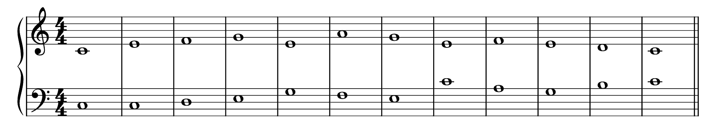
Example 12. Cantus in C, above, first species, generated by Claude Opus 4.6.
[2.22] This first species example from Claude is notable for its near absence of errors; the output is close to what a human counterpoint student might produce. The only questionable passage is the leap from E to C in mm. 7 and 8, which, although permitted by the guide as a minor sixth, sounds somewhat abrupt in context. A more linear solution would have been to sustain the E in m. 8 to form an octave, or to move to G for a sixth, thereby preserving the melodic flow. One may conjecture that the model avoided the G precisely because it already appears in mm. 4 and 5, where the lower voice moves from E to G; the guide’s directive against repetitive patterns likely led the model to seek an alternative, resulting in the less idiomatic leap to C. The issue, however, remains one of linear elegance rather than of rule compliance. It is also worth noting that the guide proscribes three consecutive repetitions of the same interval, a constraint that Claude respects here, producing a well-balanced alternation between thirds and sixths. The cadence is correctly realized. Overall, this example suggests that Claude can, in favorable configurations, generate first species counterpoint that is rule-compliant and stylistically plausible.
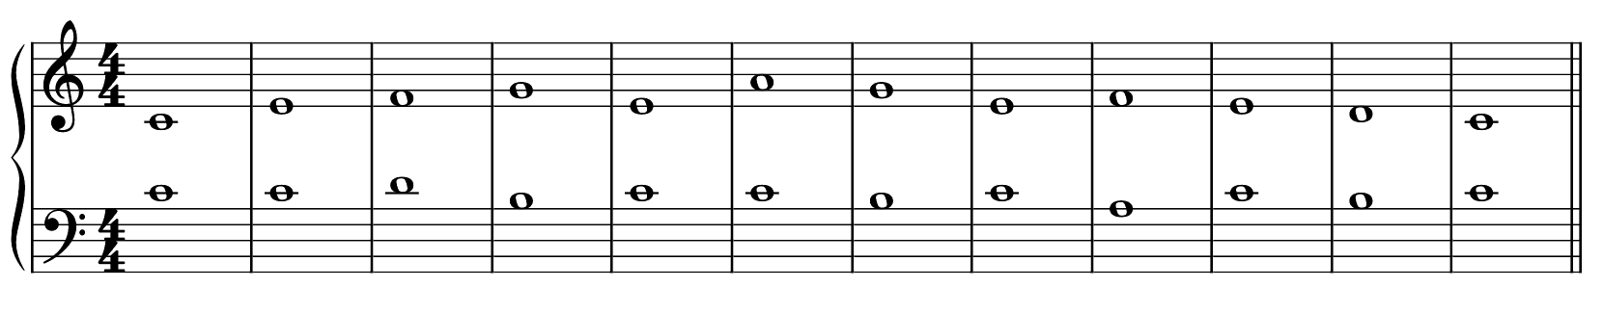
Example 13. Cantus in C, above, first species, generated by ChatGPT (GPT-5.4).
[2.23] This ChatGPT output invites direct comparison with the preceding Claude example, revealing a markedly different registral strategy. By opening with a unison, the generated voice remains near the cantus firmus throughout. Thirds and sixths are well distributed, never exceeding the triple repetition limit prescribed by the guide. One may observe, however, that fifths are entirely absent, a choice that, while not incorrect, forgoes an opportunity for greater intervallic variety. Apart from the descending fourth at the opening, the generated counterpoint moves almost entirely by conjunct motion, demonstrating a capacity to produce smooth voice leading. The result is a convincing solution, one that a human student could well have written and that presents no rule violations.
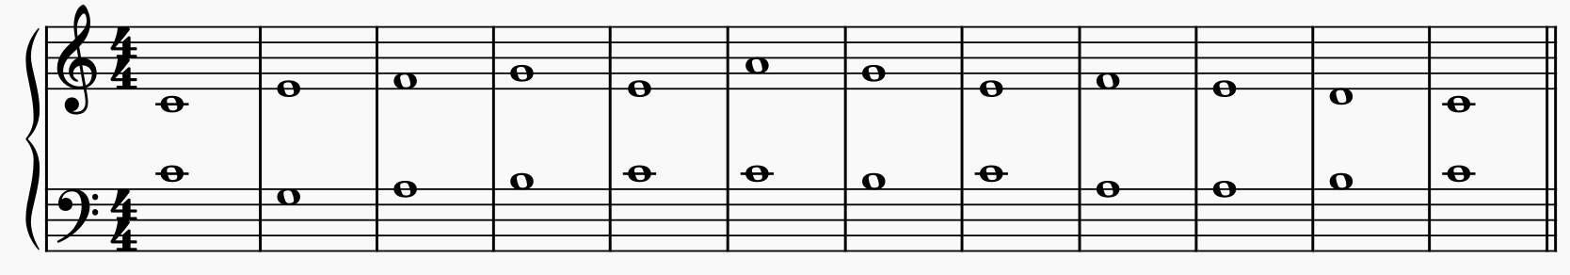
Example 14. Cantus in C, above, first species, generated by Gemini 3.1 Pro.
[2.24] Example 14 is likewise entirely correct, with no rule violations to report. Of particular interest is the use of the fifth in m. 10, approached by oblique motion, which renders the interval fully legitimate and introduces a higher degree of consonant variety absent from the other two examples presented here. It is also worth noting that both Gemini and ChatGPT employ oblique motion, whereas Claude does not in a comparable context. This suggests that Gemini and ChatGPT treated oblique motion as an additional resource for finding alternative contrapuntal paths, whereas Claude did not consider this option, which in turn may explain the more disjunct, leap-driven character of its melodic line.

Second Species
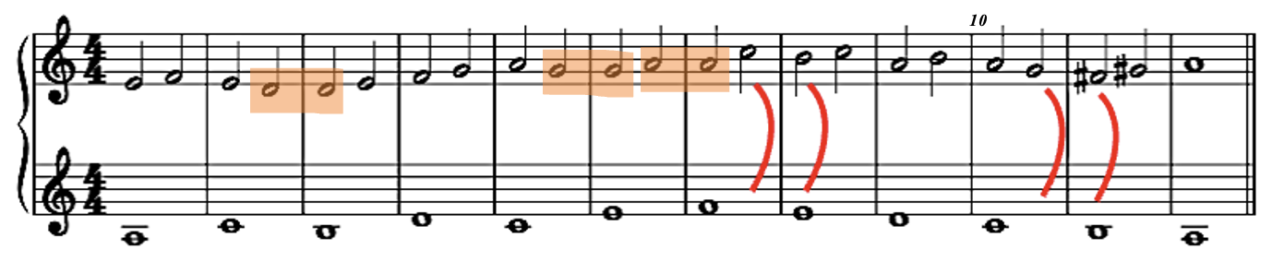
Example 15. Cantus in A, below, second species, generated by Claude Opus 4.6.
[2.25] Two recurring problems in this Claude generation point to difficulties in producing voice leading that is both smooth and rule-compliant. The first concerns parallel fifths: mm. 7–8 and 10–11 each contain parallel fifths in an arsis-thesis configuration, a violation that appears twice within the same example (see the red marks in Example 15). The G in m. 10 is further problematic, as it creates a false relation with the cadential G# a measure later. The second problem is note repetition, which the second species guide explicitly prohibits. This occurs three times over the course of the generation, far too frequently to sustain the conjunct motion the model appears to be attempting. One can sense an effort toward stepwise movement, but the repeated notes undermine precisely the linear fluency they seem designed to serve. On a more positive note, the opening and cadential motion are well controlled, the generated voice remains within a desirable range, and the rhythmic structure is consistent throughout. This is what makes the example frustrating to evaluate: the model appears to be close to being able to produce competent second species counterpoint, and the broader contour of the line suggests a genuine engagement with the guide’s directives, yet the parallel fifths and repeated notes prevent the result from reaching that level.
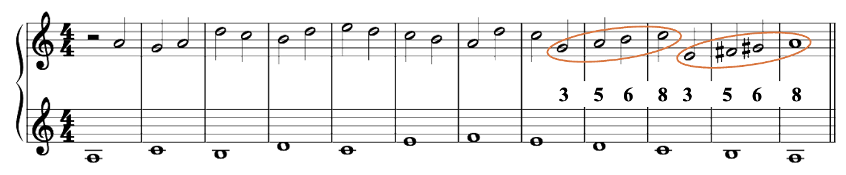
Example 16. Cantus in A, below, second species, generated by Gemini 3.1 Pro.
[2.26] As the statistical analysis confirms, Gemini performs strongly in second species, and this example offers a representative illustration of that finding. The opening is well handled: Gemini begins with an upbeat that moves to a fifth by contrary motion in m. 2. The cadential movement is equally convincing, with a characteristic ascending line toward the octave that includes the two accidentals required by the mode, executed in contrary motion in the most Fuxian manner. This suggests a good interpretation of the guide’s cadential prescriptions. The model also demonstrates a capacity for smooth voice leading, as in mm. 5 and 6, where the passing notes move conjunctly with the correct consonant intervals on the downbeats, and in mm. 7 and 8, where a characteristic leap of a fourth in second species permits the voice to reach a new registral position from which stepwise motion can resume.
[2.27] The example is not without problems, however. The octave reached on the downbeat of m. 10 is problematic insofar as it produces a sense of cadential motion toward C. In a broader compositional context, such a gesture might constitute a legitimate medial cadence, since C is among the tones on which one may cadence in the Aeolian mode (Jeppesen [1939] 1992, 82). In strict species counterpoint, however, the cadence must occur on the final, which in this case is A; the octave on C therefore creates a false sense of modal resolution. It is precisely for this reason that octaves on the downbeat are proscribed in the second species section of the guide. Moreover, the motion toward this octave generates a sequential intervallic pattern that is then repeated a third lower to reach the true cadence on A, compounding the impression of a misplaced tonal orientation. A student working through this exercise would be expected to find an alternative solution at this juncture, and the passage therefore illustrates a limitation of the model in maintaining modal coherence over a longer span.
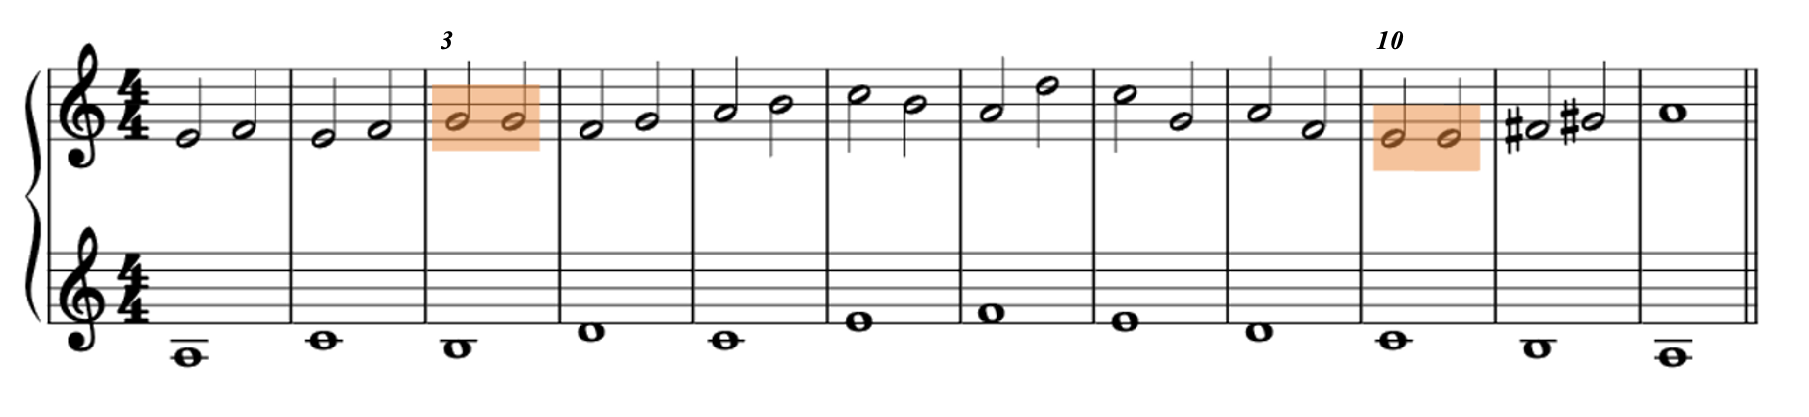
Example 17. Cantus in A, below, second species, generated by ChatGPT (GPT-5.4).
[2.28] ChatGPT shares some of Claude’s difficulties. The generation contains two note repetitions in a thesis-arsis order in mm. 3 and 10, and the recurring E-F pattern at the opening lacks melodic variety. Together, these features suggest a similar struggle to sustain a well-moving, inventive line. This assessment must be tempered, however, by passages of genuine quality. From mm. 4 through 9, the model produces a smooth contrapuntal line, employing the same characteristic leaps of a fourth observed in the Gemini example. The cadential motion is also correctly realized. In this configuration, ChatGPT appears to occupy an intermediate position between Gemini’s more assured handling of second species and Claude’s more uneven output.

Third Species
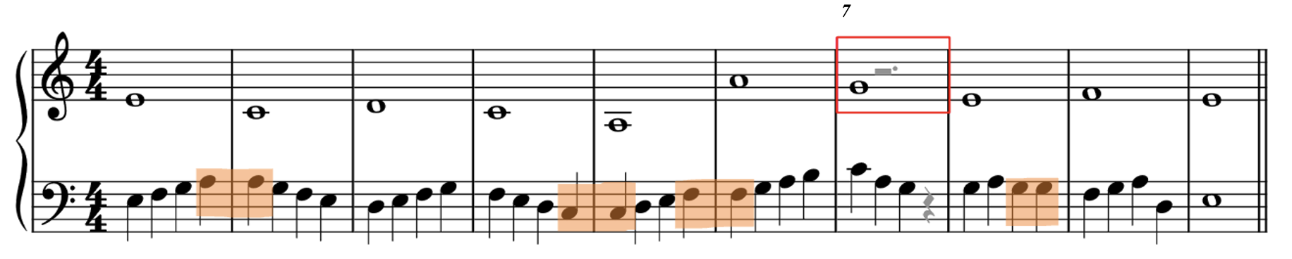
Example 18. Cantus in E, above, third species, generated by ChatGPT (GPT-5.4).
[2.29] Example 18 is interesting for two reasons. First, it displays four instances of note repetition. Three occur on the fourth beat, carried over to the first beat of the following measure, a configuration clearly forbidden by the guide and stylistically alien to the third-species framework. The fourth instance appears in m. 8, between beats three and four. The second anomaly appears in m. 7, where ChatGPT has generated an incomplete measure in the lower voice, breaking the flow of quarter notes. The upper voice presents an analogous problem, with an oversized measure combining a whole note and a dotted half rest. These issues are representative of the type of noise generation encountered throughout testing, in which the LLM deviates from the expected output for reasons that remain opaque at the output level and fails to adhere to the encoding instructions required to produce a clean output file.
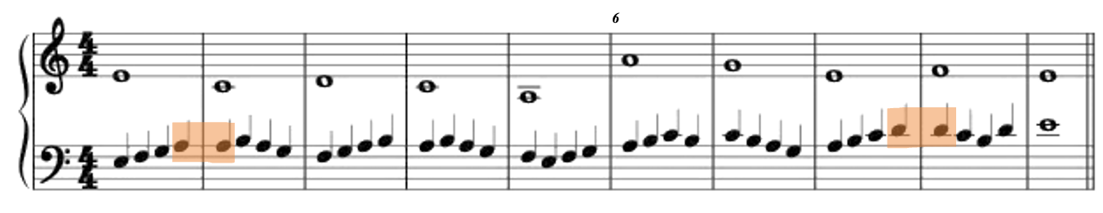
Example 19. Cantus in E, above, third species, generated by Claude Opus 4.6.
[2.30] This Claude output in third species presents several problems that merit attention. First, the note repetition observed in Claude’s second-species output recurs here: the A is repeated in m. 14, and a further repetition appears in mm. 8 and 9. Second, the tritone poses difficulties at two levels. Melodically, the relation between F and B in m. 3 outlines a tritone, a configuration the guide explicitly discourages. Vertically, the tritone appears in the penultimate measure, a particularly problematic location given the cadential context. This tritone would call for a C-E resolution, but such a resolution cannot be achieved because the cadential constraints require the voices to conclude on a unison, in this case on E. The tritone thus creates an expectation that the cadential framework cannot fulfill, rendering its use illegitimate in this context. Third, the direct octave in m. 6 constitutes a violation of one of the most fundamental rules of counterpoint, and its presence in the output is difficult to excuse.
[2.31] Not everything in this example is without interest, however. The neighboring tone E on the fourth beat of m. 6 reveals a moment of constrained decision-making worth examining. Had the model chosen D at that point, parallel fifths would have resulted; had it continued with a downward passing tone, the line would have arrived on A at the downbeat of m. 7, producing a dissonance. The model appears to have navigated around both traps by selecting a neighboring note instead, creating a brief oscillation between the third beat of m. 6 and the second beat of m. 7. The solution is not very elegant, but it avoids at least the more serious violations that the alternatives would have entailed. This passage suggests that the model can, at a local level, negotiate competing constraints, even when the broader line suffers from the repetitive patterns and tritone relations described above.
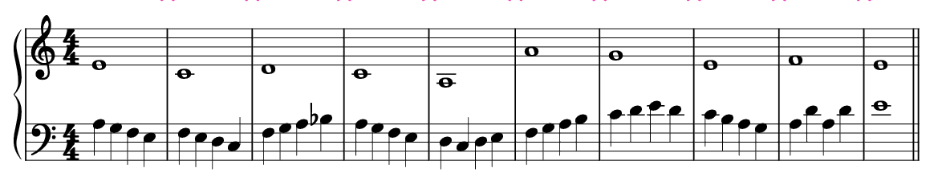
Example 20. Cantus in E, above, third species, generated by Gemini 3.1 Pro.
[2.32] This Gemini’s third species output invites direct comparison with Claude’s version on the same passage. In m. 3, where Claude outlines a tritone between F and B, Gemini resolves the problem by substituting B♭ for B-natural, thereby eliminating the tritone outline and demonstrating a capacity to detect and address this melodic constraint. This attentiveness to melodic coherence is characteristic of the generation as a whole. The counterpoint moves in near-constant stepwise motion throughout, and the few leaps that occur are well placed within the melodic line and entirely legitimate. It is also worth noting that where Claude produces a direct octave at the corresponding point, Gemini arrives instead at a tenth, a significantly more elegant move that avoids the direct motion problem while maintaining a wider registral separation between the voices. The cadential formula may appear surprising at first glance, but is, in fact, consistent with a formula that Fux himself employs in his worked examples; the model is here drawing directly on the resource provided in the guide.
[2.33] The one notable problem concerns the opening. Since the cantus firmus is in E, the first note of the counterpoint should also be E; Gemini begins instead on A, implying a different modal orientation. This is a configuration that Fux himself explicitly proscribes: although the rule is stated in the context of first species, it applies to all species (Fux [1725] 1965, 31). This reservation aside, the generation is among the stronger third species outputs in the corpus.

Fourth Species
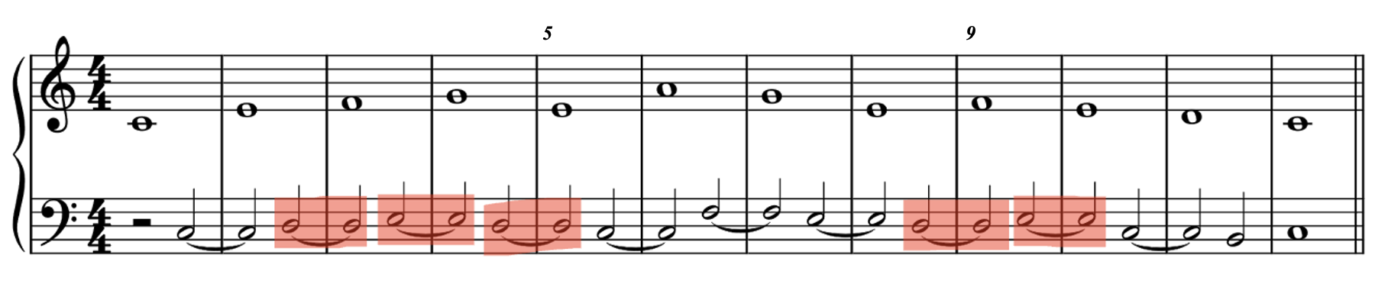
Example 21. Cantus in C, above, fourth species, generated by Claude Opus 4.6.
[2.34] The statistically weak performance of Claude in the fourth species finds a more concrete explanation here. Claude appears unable to interpret the concept of dissonance contained in the guide with sufficient accuracy: on a total of ten syncopations, five are incorrect because the preparation is itself a dissonance rather than a consonance (see the red marks signaling improper use of syncopation). The consonance-to-dissonance schema that governs fourth species appears to be inverted by the model, though not systematically. Between mm. 5 and 8, the chain of syncopations is handled correctly, with a proper consonant preparation permitting the leap to a new syncopation in mm. 9 and 10, and a legitimate use of the octave on the downbeat of m. 8. The cadential movement and its entailed syncopation are also realized in correct Fuxian form. The problem is therefore not one of total incomprehension but of inconsistent application: the model demonstrates that it can produce localized forms of fourth species writing but fails to sustain this capacity across the full span of the exercise.
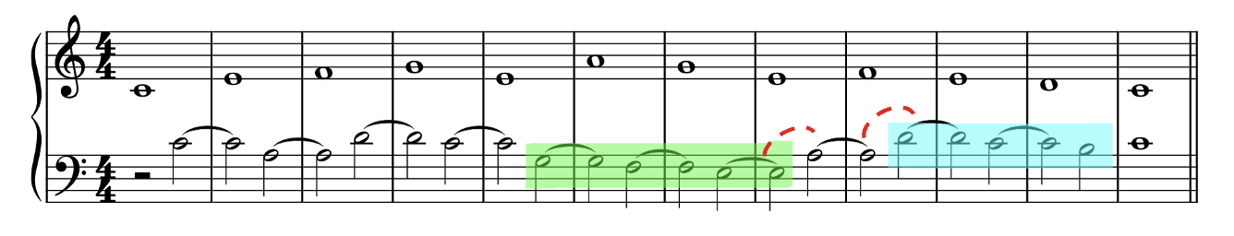
Example 22. Cantus in C, above, fourth species, generated by ChatGPT (GPT-5.4).
[2.35] This ChatGPT-generated solution contains no major errors and is well-constructed. In mm. 1–3, two successive consonant syncopations are used, connected by a leap. This is followed in m. 4 by a fourth that is correctly prepared by a third and resolves downward onto a fifth. The remainder of the exercise contains two chains of dissonant syncopations (marked in green and blue in Example 22), which constitute the highlight of the generation and produce the characteristic suspended quality of fourth species counterpoint. The only questionable passage is the succession of two melodic fourths in the counterpoint line, E-A-D. While the resulting suspension chain is technically well formed, two consecutive leaps of a fourth outline a dissonant seventh, a configuration generally proscribed in species counterpoint on the grounds that successive leaps should outline consonant intervals (Jeppesen [1939] 1992, 86).
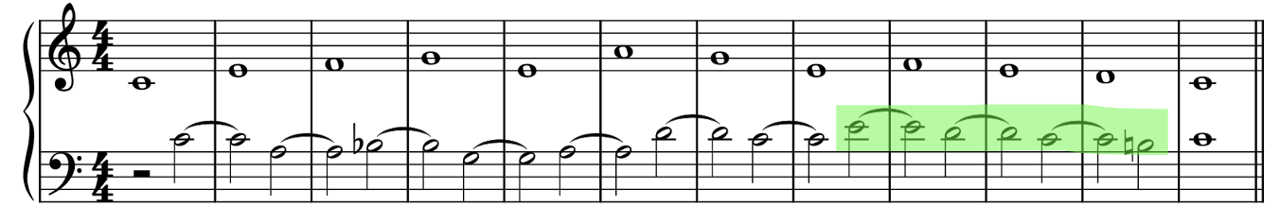
Example 23. Cantus in C, above, fourth species, generated by Gemini 3.1 Pro.
[2.36] Finally, Gemini produced a markedly different solution on the same cantus firmus. The interval pool is notably rich, featuring a balanced mix of consonant and dissonant syncopations. Gemini respects the conventional limit of no more than three consecutive syncopations of the same type and offers an impressive chain of three consecutive 2-3 suspensions initiated by a legitimate unison, as prescribed in the guide. This chain creates a compelling cadential motion and places the melodic climax in the final portion of the exercise, consistent with the principle that the climax should appear toward the end of the line (Lewin 1983, 43). The necessity of reaching this chain of dissonances means that Gemini does not face the same constraints as Claude in the earlier measures and must leap sooner to position the counterpoint line for this critical passage. As a result, the double-fourth constellation noted in the ChatGPT version is avoided altogether here. The generation displays a strong capacity for reasoning about dissonance planning and for correctly interpreting the interrelated set of rules encoded in the guide.
[2.37] Another remarkable feature is Gemini’s ability to identify demanding solutions and deploy them in a stylistically appropriate manner. The B♭ in m. 3 provides a telling example. Where ChatGPT selected a D in the same metric position, Gemini appears to have evaluated a broader solution space, recognizing the possibility of flattening the B in order to avoid a vertical tritone. This behavior closely resembles what a human composer might arrive at through iterative evaluation of available pitch choices.

Fifth Species
[2.38] Fifth species is by far the most complex and demanding task for the models to solve. As the statistical results show, no model produced violation-free generation in this species. Since the statistical analysis already documents the general difficulties encountered by all three models, we instead chose to present some of the best generations from the entire corpus, drawn from the low-violation tier of the distribution (M2), to showcase each model at its best. This entails a methodological departure from the approach adopted for the other species: rather than comparing three generations against the same cantus firmus, we selected one of the strongest outputs for each model, regardless of the cantus firmus used, because when a given model produced a strong result on a particular cantus firmus, the other two models typically performed poorly on that same cantus, making direct comparison less informative than in the preceding species.
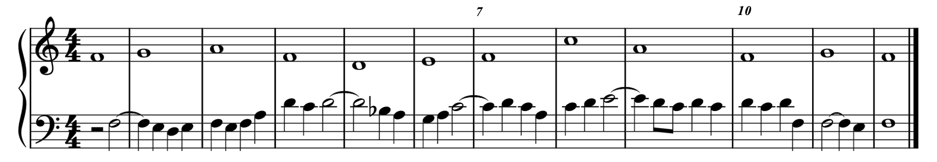
Example 24. Cantus in C, below, fifth species, generated by Claude Opus 4.6.
[2.39] Example 24 illustrates visually one of the recurring difficulties of the generation process. As the statistical observations confirm, generating the counterpoint voice in the lower part has generally proved more problematic, and this Claude output makes that tendency explicit. In m. 7, the dissonant fourth is resolved improperly: a downward resolution would produce a tritone, yet no adjustment is made to avoid it. The preparation of the dissonance is correct, however, which is unfortunately not the case in the antepenultimate measure, where the dissonant fourth is correctly placed, but its preparation does not sustain a half note, and the resolution arrives too late, falling on the fourth beat rather than the third. It should be noted that not all dissonances are handled incorrectly. In mm. 8 and 9, the syncopated fourth is correctly prepared by a sixth, features an ornamented dissonance, and resolves properly to the fifth. One can deduce from this contrast that the difficulty is highly localized: the model struggles to find a correct solution within specific contrapuntal configurations rather than failing systematically. A further problem is, once again, melodic repetition, as shown in mm. 9 and 10 with the recurring series of D and C. Although the guide explicitly discourages such repetition, Claude struggles here to produce a line that sounds both innovative and plausible to a human ear. This difficulty, moreover, appears to have influenced the dissonance error in the cadential movement. The direct octave in m. 8 could have been avoided had an E been used instead of a C; the incorrect dissonance in m. 7 created a constrained surrounding that made it difficult to prevent this parallel motion. This example thus demonstrates how a single localized error can propagate through the contrapuntal texture, compounding difficulties the model cannot resolve independently.
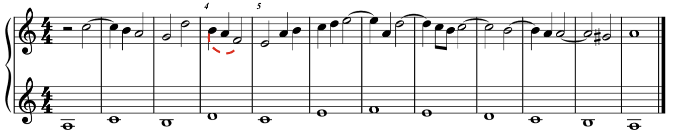
Example 25. Cantus in C, above, fifth species, generated by Gemini 3.1 Pro.
[2.40] The most significant problem in Example 25, which displays a Gemini generation, occurs at m. 4, where the counterpoint outlines a tritone. Beyond this deficiency, however, the remainder of the example flows convincingly within the idiom of Fuxian counterpoint. From m. 5 onward in particular, the generated voice exhibits the full range of what one expects from a florid counterpoint: varied rhythmic values, ornamentation of the syncopation through an accentus figure, tone repetition, and eighth-note passages. The repetition of A in the antepenultimate measure is especially characteristic of the Palestrina style. Although five 7-6 syncopations occur within this span, the alternation between ornamented and unornamented forms of the suspension breaks any sense of mechanical repetition and may be understood as a reasonable license on the principle that no more than three identical consecutive syncopation types should appear. The tritone in m. 4 remains regrettable, but the generation can be categorized unmistakably as a florid counterpoint.
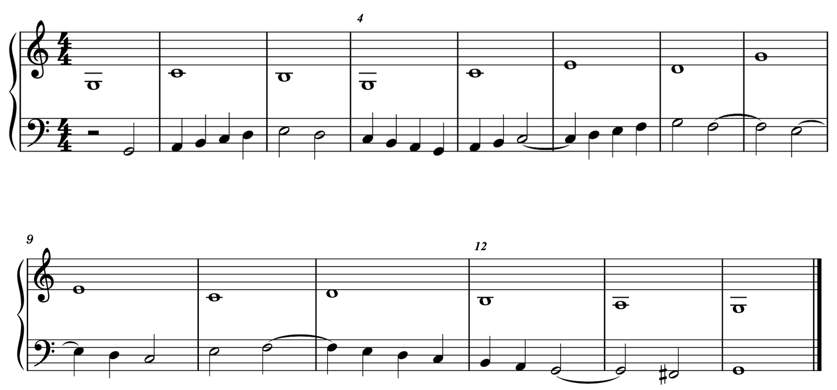
Example 26. Cantus in C, below, fifth species, generated by ChatGPT (GPT-5.4).
[2.41] Of the three models, ChatGPT produced the generation with the most remarkable melodic flow (Example 26), featuring well-shaped ascending and descending motion that is, for the most part, contrapuntally justified. Notably, this result was achieved with the cantus firmus placed above the counterpoint, a configuration that the statistical analysis identified as the most challenging for all three models. The only errors occur on the downbeat of mm. 4 and 12, where a direct fifth and a direct octave appear respectively. These two violations constitute the sole infractions in the entire generation. The florid counterpoint displays a genuine variety of rhythmic values and idiomatic configurations, even though no eighth notes are present. No major repetitive patterns occur, and the final cadence resumes the syncopation procedure as prescribed, confirming that the guide proved effective in steering ChatGPT toward producing a well-formed florid counterpoint.

Conclusion
[3.1] Contemporary large language models, when guided by carefully formulated natural-language instructions, can produce species counterpoint whose most successful instances approach the rule-compliance of a competent student. Such instances remain exceptional rather than typical: across the corpus, the majority of generations contain at least one violation, entirely error-free outputs are rare, and even explicit instruction does not eliminate a residual margin of error.
[3.2] The CAMBIATA workflow, combining species guides authored on the basis of Fux’s pedagogical framework with automated evaluation over 450 generations, has enabled assessment of this claim both statistically and through close reading of the musical output. The statistical analysis identifies three regularities that hold consistently across the three models surveyed. The first concerns the model hierarchy: Gemini achieves the lowest mean violation count at 3.37 per run, ChatGPT occupies an intermediate position at 3.98, and Claude shows the weakest rule compliance at 8.92. The second concerns species difficulty: the first species is systematically the easiest of the five, and the third species systematically the hardest, with the second, fourth, and fifth species occupying a middle range whose internal ordering varies somewhat across models. The third recurring problem is positional: all three models commit more violations when the counterpoint lies below the cantus firmus than when it lies above, an asymmetry that holds across species.
[3.3] Beyond these shared regularities, each model exhibits a distinct error signature. Gemini’s outputs suggest a capacity for planning across longer spans: its fourth-species chains of suspensions are well positioned within the line, its fifth-species generations display a solid competence in florid writing, and it commits no species-specific violation at all in second species. A paradox nevertheless remains around the tritone: as documented in M3, Gemini’s evident command of vertical tritone management does not transfer to the outlined form, which it produces more frequently than any other model in the study. ChatGPT occupies an intermediate position that resists straightforward characterization. Its most distinctive statistical feature is a high concentration of non-conforming cadences, unmatched by the other two models; yet it achieves the lowest mean violation count in fourth species (2.47 against Gemini’s 2.83), essentially matches Gemini in third (7.67 against 7.63), and its fifth-species generation produced the most compelling melodic flow in the corpus. When ChatGPT succeeds, it can reach a level of contrapuntal competence that neither of the other models consistently matches. Claude’s difficulties, finally, prove the most systematic: the qualitative analysis traces them to an inconsistent interpretation of the consonance-to-dissonance schema, in which localized errors propagate through the contrapuntal texture and compound into broader non-compliance. Dissonance treatment alone accounts for 30% of its violations, and 77% of all unique Claude runs contain at least one dissonance infraction; beyond first species, the model does not produce a single perfect run, and its fourth-species average more than doubles from 4.87 above the cantus firmus to 11.87 below. The pattern suggests a model that has acquired a partial grasp of the contrapuntal framework: locally, individual voice-leading decisions may conform to the guide’s directives, but the sustained coordination of those decisions across the full duration of an exercise proves unreliable, particularly where the rules shift according to voice position. Whether this inconsistency reflects a failure to internalize the relevant sections of the species guide, or a structural limitation in the model’s capacity to maintain position-dependent rule sets, remains an open question that the present methodology has not been able to resolve.
[3.4] The experiment also brought to light a phenomenon with methodological implications well beyond this study: the unintended duplication of outputs across independent runs of generation, as documented above. Under the highly constrained conditions of a species counterpoint exercise, the models’ sampling process collapses toward a single solution for a given prompt, effectively neutralizing the stochastic dimension of the generation. Whether this convergence reflects a property of the task (a solution space small enough that the most probable path dominates), a property of the models’ internal decoding machinery (which remains outside the experimenter’s reach even at fixed sampling settings), or an interaction between the two, remains open. Future studies that employ repeated generation to measure model variability should treat duplicate detection as a routine preprocessing step.
[3.5] Much remains to be done. In its current design, CAMBIATA operates as a single-pass system, with no mechanism for the model to revise its output in light of identified violations. An agentic architecture incorporating the rule checker’s feedback into iterative prompting would bring the workflow closer to the process by which human students improve their counterpoint through correction. A hybrid methodology that combines explicit rule documentation with statistical patterns extracted from a corpus of model counterpoints represents a further avenue, though it raises its own questions about how to weight the two sources of constraint. Finally, the extension to three- and four-voice counterpoint constitutes a natural next step and a meaningful test of the scalability of the CAMBIATA approach.

Works Cited
Anthropic. n.d. “Create a Message.” Anthropic API Reference. Accessed April 3, 2026. https://platform.claude.com/docs/en/api/messages.
Brown, Tom B., Benjamin Mann, Nick Ryder, Melanie Subbiah, Jared Kaplan, Prafulla Dhariwal, Arvind Neelakantan, et al. 2020. “Language Models are Few-Shot Learners.” In Advances in Neural Information Processing Systems 33, edited by H. Larochelle, M. Ranzato, R. Hadsell, M. F. Balcan, and H. Lin, 1877–1901. Curran Associates.
Cope, David. 1989. “Experiments in Musical Intelligence (EMI): Non-Linear Linguistic-Based Composition.” Interface 18 (1–2): 117–39. https://doi.org/10.1080/09298218908570541.
Cope, David. 1996. Experiments in Musical Intelligence. Computer Music and Digital Audio Series 12. A-R Editions.
Cuthbert, Michael Scott, and Christopher Ariza. 2010. “music21: A Toolkit for Computer-Aided Musicology and Symbolic Music Data.” In Proceedings of the 11th International Society for Music Information Retrieval Conference (ISMIR 2010), 637–42. ISMIR.
Dai, Congren, Yue Yang, Krinos Li, Huichi Zhou, Shijie Liang, Bo Zhang, Enyang Liu, et al. 2025. “Musical Score Understanding Benchmark: Evaluating Large Language Models’ Comprehension of Complete Musical Scores.” arXiv:2511.20697. Forthcoming in Proceedings of the 64th Annual Meeting of the Association for Computational Linguistics. https://arxiv.org/abs/2511.20697.
Fux, Johann Joseph. (1725) 1965. The Study of Counterpoint from Johann Joseph Fux’s Gradus ad Parnassum. Translated and edited by Alfred Mann, with the collaboration of John Edmunds. Rev. ed. W. W. Norton.
Google. n.d. “Text Generation.” Gemini API | Google AI for Developers. Accessed April 3, 2026. https://ai.google.dev/gemini-api/docs/text-generation.
Green, Douglass M., and Evan Jones. 2011. The Principles and Practice of Modal Counterpoint. Routledge.
Hadjeres, Gaëtan, François Pachet, and Frank Nielsen. 2017. “DeepBach: A Steerable Model for Bach Chorales Generation.” In Proceedings of the 34th International Conference on Machine Learning (ICML 2017), edited by Doina Precup and Yee Whye Teh, 1362–71. PMLR 70.
Herremans, Dorien, and Kenneth Sörensen. 2012. “Composing First Species Counterpoint with a Variable Neighbourhood Search Algorithm.” Journal of Mathematics and the Arts 6 (4): 169–89. https://doi.org/10.1080/17513472.2012.738554.
Herremans, Dorien, and Kenneth Sörensen. 2013. “Composing Fifth Species Counterpoint Music with a Variable Neighborhood Search Algorithm.” Expert Systems with Applications 40 (16): 6427–37. https://doi.org/10.1016/j.eswa.2013.05.071.
Jeppesen, Knud. (1939) 1992. Counterpoint: The Polyphonic Vocal Style of the Sixteenth Century. Translated by Glen Haydon. Dover.
Kojima, Takeshi, Shixiang Shane Gu, Machel Reid, Yutaka Matsuo, and Yusuke Iwasawa. 2022. “Large Language Models are Zero-Shot Reasoners.” In Advances in Neural Information Processing Systems 35, 22199–213. Curran Associates.
Komosinski, Maciej, and Piotr Szachewicz. 2015. “Automatic Species Counterpoint Composition by Means of the Dominance Relation.” Journal of Mathematics and Music 9 (1): 75–94. https://doi.org/10.1080/17459737.2014.935816.
Lamotte, Anton. 2024. “FuxCP: Constraint Programming Formalisation of Three-Voice Counterpoint According to Fux.” Master’s thesis, Ecole polytechnique de Louvain, Université catholique de Louvain. http://hdl.handle.net/2078.1/thesis:43960.
Lewin, David. 1983. “An Interesting Global Rule for Species Counterpoint.” In Theory Only 6 (8): 19–44.
Lewin, David. 1985. “Led Zeppelin Fake Book.” Course materials, Music 155A, Harvard University, Fall 1985.
Long, Phillip, Zachary Novack, Taylor Berg-Kirkpatrick, and Julian McAuley. 2025. “PDMX: A Large-Scale Public Domain MusicXML Dataset for Symbolic Music Processing.” In ICASSP 2025: 2025 IEEE International Conference on Acoustics, Speech and Signal Processing. IEEE. https://arxiv.org/abs/2409.10831.
Mundada, Gagan, Yash Vishe, Amit Namburi, Xin Xu, Zachary Novack, Julian McAuley, and Junda Wu. 2025. “WildScore: Benchmarking MLLMs in-the-Wild Symbolic Music Reasoning.” In Proceedings of the 2025 Conference on Empirical Methods in Natural Language Processing, 16847–63. Association for Computational Linguistics.
Padilla, Víctor, and Darrell Conklin. 2018. “Generation of Two-Voice Imitative Counterpoint from Statistical Models.” International Journal of Interactive Multimedia and Artificial Intelligence 5 (3): 22–32. https://doi.org/10.9781/ijimai.2018.10.002.
Pond, Liam, and Ichiro Fujinaga. 2025. “Teaching LLMs Music Theory with In-Context Learning and Chain-of-Thought Prompting: Pedagogical Strategies for Machines.” In Proceedings of the 17th International Conference on Computer Supported Education (CSEDU 2025), Volume 1, 671–81. SCITEPRESS. https://doi.org/10.5220/0013506100003932.
Schottstaedt, Bill. 1984. “Automatic Species Counterpoint.” Report No. STAN-M-19. Center for Computer Research in Music and Acoustics (CCRMA), Department of Music, Stanford University.
Schubert, Peter. 2008. Modal Counterpoint, Renaissance Style. 2nd ed. Oxford University Press.
Shanahan, Murray, Kyle McDonell, and Laria Reynolds. 2023. “Role Play with Large Language Models.” Nature 623 (7987): 493–98. https://doi.org/10.1038/s41586-023-06647-8.
Wafflard, Thibault. 2023. “FuxCP: A Constraint Programming Based Tool Formalizing Fux’s Musical Theory of Counterpoint.” Master’s thesis, Ecole polytechnique de Louvain, Université catholique de Louvain. http://hdl.handle.net/2078.1/thesis:40739.
Wang, Zhilin, Zhe Yang, Yun Luo, Yafu Li, Xiaoye Qu, Ziqian Qiao, Haoran Zhang, et al. 2025. “Towards an AI Musician: Synthesizing Sheet Music Problems for Musical Reasoning.” arXiv:2509.04059. https://arxiv.org/abs/2509.04059.
Wei, Jason, Xuezhi Wang, Dale Schuurmans, Maarten Bosma, Brian Ichter, Fei Xia, Ed H. Chi, Quoc V. Le, and Denny Zhou. 2022. “Chain-of-Thought Prompting Elicits Reasoning in Large Language Models.” In Advances in Neural Information Processing Systems 35, 24824–37. Curran Associates.
Weng, Yixuan, Minjun Zhu, Fei Xia, Bin Li, Shizhu He, Shengping Liu, Bin Sun, Kang Liu, and Jun Zhao. 2023. “Large Language Models Are Better Reasoners with Self-Verification.” In Findings of the Association for Computational Linguistics: EMNLP 2023, 2550–75. Association for Computational Linguistics. https://doi.org/10.18653/v1/2023.findings-emnlp.167.
Yuan, Ruibin, Hanfeng Lin, Yi Wang, Zeyue Tian, Shangda Wu, Tianhao Shen, Ge Zhang, et al. 2024. “ChatMusician: Understanding and Generating Music Intrinsically with LLM.” In Findings of the Association for Computational Linguistics: ACL 2024, 6252–71. Association for Computational Linguistics. https://doi.org/10.18653/v1/2024.findings-acl.373.
Zhao, Jiahao, Yunjia Li, Wei Li, and Kazuyoshi Yoshii. 2025. “ABC-Eval: Benchmarking Large Language Models on Symbolic Music Understanding and Instruction Following.” arXiv:2509.23350. https://arxiv.org/abs/2509.23350.

Anthropic describes temperature as the “amount of randomness injected into the response” and recommends values closer to 0.0 for analytical tasks, while noting that even at a temperature of 0.0 results will not be fully deterministic (Anthropic n.d.). Google explicitly advises against lowering the temperature below 1.0 for Gemini, warning that doing so may lead to unexpected behavior such as looping or degraded performance in complex reasoning tasks (Google n.d.).
see rule U12 in the evaluation guide
The cantus in D was excluded, as noted earlier, to serve as a reference example.
The standard deviation, abbreviated SD, is a measure of dispersion: a small SD indicates that runs cluster tightly around the mean, while a large SD indicates greater variability across runs.
See in Appendix 6: U11, U12, U13.
See in Appendix 6: S1-8, S1-9, S2-5, S2-6, S3-7, S3-8, S4-7, S5-14.
See in Appendix 6: U17, S2-1, S2-2, S3-1–S3-4, S4-1–S4-5, S4-9, S5-6, S5-8.
See in Appendix 6: U3, U4, U5, U10, S1-3, S1-4, S2-4, S4-11, S5-15.
The per-run averages and category shares in Example 4 are computed on the full 450-run corpus. Rule-specific counts cited in the prose are normalized differently: they are drawn from the tally of unique runs (457 violations for ChatGPT, 858 for Claude, 321 for Gemini), and a species-specific rule is counted against the 30 unique runs of its species. The violation count per rule across the entire corpus is reported in Appendix 6, section 4.
The recurring patterns are duplicate </pitch> tags, premature </note> closures, and missing opening <duration> elements; the five error patterns identified are documented with the repair methodology in the supplementary materials.

